**FOR IMMEDIATE RELEASE**

**January 2020**

**Christina Kann, Publicist**

brandylanepr@gmail.com or 804.644.3090

**“An Optimistic Outlook for Sustainability”:** ***A Tree for a Year***

**written by Ellen Dutton**

**illustrated by Emily Hurst Pritchett**

**on sale January 16, 2020**

“Dutton weaves a whimsical tale of personal growth through a proverbial walk in someone--or something--else’s shoes. *A Tree for a Year* offers an optimistic outlook for sustainability, uplifting the choices available to humans to thrive in unity with the ecosystems we inhabit. The sense of shared responsibility for protecting the Earth’s trees and natural resources imparted by her story will avail readers both young, and young at heart.”

—Kate Addleson, director of the Sierra Club’s Virginia Chapter

[Brandylane Publishers, Inc.](http://www.brandylanepublishers.com) of Richmond, Virginia, is excited to announce the upcoming release of a new children’s book, [*A Tree for a Year*](https://www.amazon.com/Tree-Year-Ellen-Dutton/dp/1947860690/ref=sr_1_1?keywords=tree+for+a+year+dutton&qid=1574261692&s=books&sr=1-1). A heartfelt fable of conservation and understanding for readers of all ages, *A Tree for a Year* is scheduled for release on January 16, 2020.

[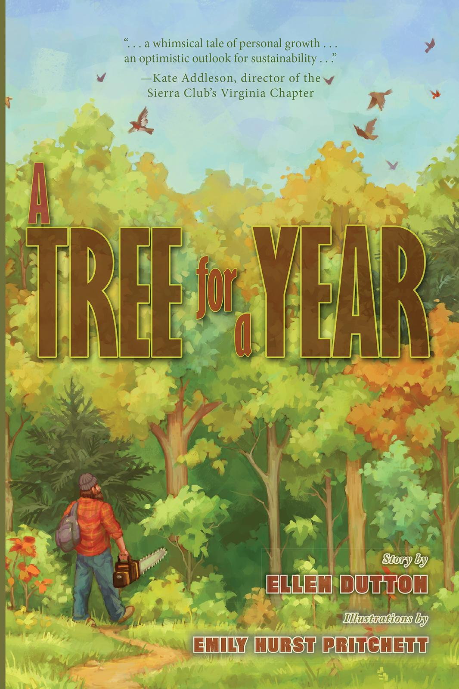](https://www.amazon.com/Tree-Year-Ellen-Dutton/dp/1947860690/ref=sr_1_1?keywords=tree+for+a+year+dutton&qid=1574261692&s=books&sr=1-1)

The forest is a beautiful place, full of many different animals, tall trees, and a crystal-clear river. But when Man appears, he cuts down trees and scatters litter on the ground. Soon, the animals find their home threatened and decide they must come up with a plan to change Man’s ways. How can the animals show Man the true beauty and importance of their home? To understand the forest, Man must become a part of it. With Mother Nature’s help, Man is transformed in ways he never thought possible. But will a change in Man’s ways take root?

**About the Author**

Born and raised in Chicago, IL, Ellen Dutton was fortunate to grow up near the woods of the Forest Preserves. Her time spent there, during all seasons, planted the passion Ellen has for nature. As a biologist and an environmental educator, Ellen is now sharing that passion and promoting practices of stewardship and sustainability.

**About the Illustrator**

[Emily Hurst Pritchett](https://emilypritchettart.com/) grew up in western New York and has loved to draw and paint all her life. She studied illustration at Brigham Young University in Utah before moving back to the East Coast. She loves to read books for kids and grown-ups, sing, dance, and play video games. She currently lives in Boston, where she loves to hike in the woods with her husband and son.

**Interviews are available upon request.**

Brandylane Publishers, Inc. is an independent press located in Richmond, Virginia, that has published books since 1985.

____________

*A Tree for a Year* (48 pages, retail hardcover $22.95 / paperback $12.95 / Kindle ebook $2.99) is available for preorder from [Amazon](https://www.amazon.com/Tree-Year-Ellen-Dutton/dp/1947860690/ref=sr_1_1?keywords=tree+for+a+year+dutton&qid=1574261692&s=books&sr=1-1), [Barnes & Noble](https://www.barnesandnoble.com/w/a-tree-for-a-year-ellen-dutton/1134881535?ean=9781947860698), and other fine booksellers.