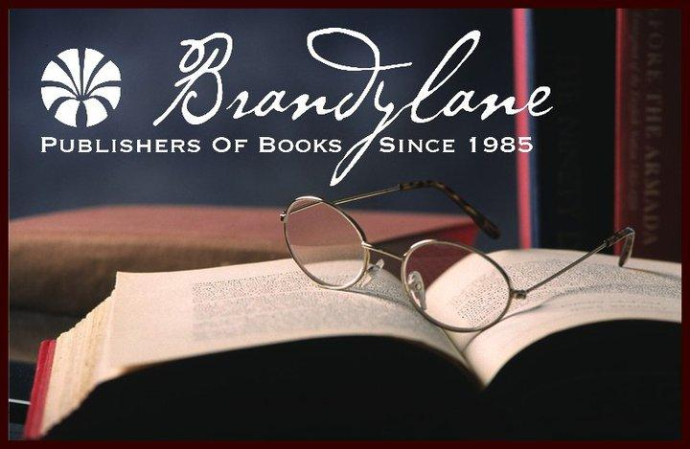
FOR IMMEDIATE RELEASE
MAY 2018

Christina Kann, Publicist
brandylanepr@gmail.com or 804.644.3090
Robert Pruett, Publisher
brandylanerhpruett@gmail.com or 804.644.3090

Confronting Our Nation’s Tragic History:
Uncle George and Me: Two Southern Families Confront a Shared Legacy of Slavery
by Bill Sizemore
On sale September 5, 2018

“…. A compelling, honest, and sometimes heartbreaking narrative that illuminates the fraught and fragile ties that yoke those on both sides of America’s founding racial divide.”
- Margaret Edds, author of We Face the Dawn:
Oliver Hill, Spottswood Robinson, and the Legal Team That Dismantled Jim Crow

Brandylane Publishers, Inc. of Richmond, Virginia is proud to announce the release of the reflective book, Uncle George and Me: Two Southern Families Confront a Shared Legacy of Slavery, written by Bill Sizemore. In this memoir, Sizemore confronts the painful history of slavery in both his family and his country. The book is scheduled for release on September 5, 2018.

In Uncle George and Me, author Bill Sizemore tells the story of his slave-owning Virginia ancestors, their slaves, and those slaves’ descendants—a story that lay buried by a century of denial and historical amnesia. Its threads run through the Civil War, Reconstruction, Jim Crow, the Great Migration, the struggle for civil rights, and the crippling legacy of slavery that still plagues the nation today. In microcosm, it is the story of Virginia and the South. In telling it, Sizemore hopes to advance an essential, if painful, national conversation about race.

About the Author: Bill Sizemore grew up in segregated small-town Virginia and spent forty-three years as a journalist, with most of that time spent at the Virginian-Pilot, the state’s largest newspaper, where he was a Pulitzer Prize finalist in 2007. He wrote about topics as varied as state government and politics, televangelist Pat Robertson, the private military company Blackwater, and Virginia’s prison-building boom. He has also written for the Associated Press, Ms. Magazine, and Virginia Quarterly Review. Since his retirement in 2014, Bill has focused on his two highest priorities: playing with his grandchildren and writing books. He lives in Williamsburg, Virginia.

For more information about the author, please visit http://www.billsizemorebooks.com/
Interviews available upon request.

Brandylane Publishers, Inc. is an independent press located in Richmond, Virginia that has published books since 1985.
____________
Uncle George and Me: Two Southern Families Confront a Shared Legacy of Slavery (paperback, 158 pages, retail $18.95) is available for pre-order from Brandylane Publishers, Amazon, Barnes & Noble, and other fine booksellers.

